WEEK 1
Series Motivation
The Data Scientist's Toolbox
Getting Help
Finding Answers
R Programming Overview
Getting Data Overview
Exploratory Data Analysis Overview
Reproducible Research Overview
Statistical Inference Overview
Regression Models Overview
Practical Machine Learning Overview
Building Data Products Overview
Installing R
WEEK 2
Command Line Interface
Introduction to Git
Introduction to Github
Creating a Github Repository
Basic Get Commands
Basic Markdown
Installing R Packages
Installing Rtools
WEEK 3
Types of Questions
What is Data?
What About Big Data?
Experimental Design

Series Motivation:
Data Science Process:
- Want to answer a question
- Use data to answer the question (Focus on the question not the data)
- Overcome obstacles
  - Having not enough data or too much data
  - Having unclean or hard to handle data
  - Having to break complicated problems into parts
  - Being the first ever to work on a certain problem (google/stackoverflow can help)
  - Creating a practical answer

Data Science Boom
- Data is cheap to gather and work with
- We have access to data we never had before (ie. GPS in cars, medical data, & genetics)
- As a result, there is high demand for data scientists

What is a data scientist? Someone who answers questions with data.

Why Statistical Data Science?
There are highly valuable answers that only statistical data science can answer
(ie. $3,000,000 contest for a better health insurance algorithm to predict hospitalization)

Why R?
- We like R because it's becoming the most used language for data science.
- Working with
  - Raw files
  - Interactive reports
  - Interactive applications
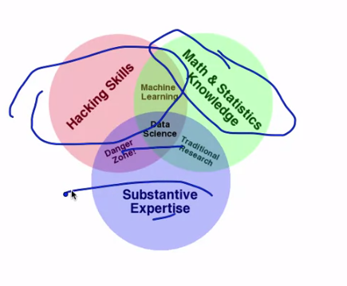
- R is free
- It has packages for all the processes in data science
- It has one of the best development environments
- A great ecosystem of developers
- Easy to install.

Goal of this Course:
- To teach many different skills and tools
that will be useful as a data scientist.
- Gain a basic background in these areas.
- Learn to use the info you have to
answer the question you'd like to answer.

The Data Scientist's Toolbox
Data Science Process:
- What software do you need
- Define the question
- Define the ideal data set
- Determine if the data can be accessed
- Obtaining the data
- Clean the data
- Exploratory data analysis (plot and look at patterns)
- Statistical prediction/modeling
- Interpret results
- Challenge results
- Synthesize/write up results
- Create reproducible code
- Distribute results to other people
  - Write ups
  - Presentations
  - Interactive apps built on R

Tools we will use in this class

Rstudio's interface (IDE)
useful mentions about the IDE:
- The file name is in the top left corner
- The bottom left has the console; used to run commands.
- On the right: plots you've recently made
- Packages you have loaded
- help files you might be interested in
You will work with “.R” and “.Rmd” files.
“.R” Example Script
# price of call option
callprice.bs ← function (s, x, r, sigma, t.exp, t)
{
d.pos ← log(s/x) + (r + 0.5 * sigma^2) * (t.exp – t)
d.pos ← d.pos/(sigma * (t.exp – t)^0.5)
d.neg ← d.pos – sigma * (t.exp – t)^0.5
s * pnorm(d.pos) – x * exp( - r * (t.exp – t)) * pnorm(d.neg)
}
“.Rmd”
- Stands for “R Markdown Documents”.
- Used to create documents that can be reproduced with the exact same numbers you got in your analysis.
- Can knit it into HTML.
Github
- To store your projects and contribute to other projects.
- Github commands will be done in the shell.

Getting Help
- Try to answer your questions yourself from google or stack overflow.
- Post your messages to the message board.
Using R Functions for help
Access help file:
?rnorm
Search Help Files:
help.search(“rnorm”)
Get Arguments:
args(“rnorm”)
See Code:
Type the function without brackets to get the code to that function
rnorm

How to ask an R question:
- What steps will reproduce the problem?
- What is the expected output?
- What do you see instead?
- What version of the product are you using?
- What operating system?

How to ask a data analysis question:
- What is the question you are trying to answer?
- What steps/tools did you use to answer it?
- What did you expect to see?
- What do you see instead?
- What other solutions have you thought about?

Examples of good questions:
- R 2.15.0 lm() function on Mac OS X 10.6.3 – seg fault on large data frame
- Using principal components to discover common variation in rows of a matrix, should I use U, D or V^{T}?

Etiquette for forums/help sites: DOs
- Describe the goal
- Be explicit
- Provide the minimum information
- Be courteous
- Follow up and post solutions
- Use the forums rather than email
Etiquette for forums/help sites: DONTs
- Immediately assume you found a bug
- Grovel as a substitute for doing your work
- Post homework questions on mailing lists
- Email multiple mailing lists at once/the wrong mailing list
- Ask others to fix your code without explaining the problem
- Ask about general data analysis questions on R forums.

Finding Answers:
Second lecture on this because it's so important. These are “Hacking Skills”.
Almost none of the knowledge you'll need can be found in standardized textbooks. It's scattered in many different places and you'll have to find it.
Examples:
- Which data set you need to be using.
- The statistical analysis you need to be doing.
- The R package you need to be using.

Key characteristics of hackers
- Willing to find answers on their own
- Knowledgeable about where to find answers on their own
- Not intimidated by new data types or packages
- Unafraid to say they don't know the answer
- Polite but relentless

Where to go for different questions
- Software specific websites
- R Programming
- http://bit.ly/Ufaadn
- Search the archive of the class forums
- Read the manual/help files
- Search on the web
- Ask a skilled friend
- Post to the class forums
- Post to the R mailing list or Stackoverflow with tag “[r]”

3. Data Analysis/Statistics
- Search the archive of the class forums
- Search on the web
- Ask a skilled friend
- Post to the class forums
- Post to CrossValidated
4. Google
1. Use “[data type] data analysis” or “[data type] R package”
2. Data science might go by these names instead:
1. Biostatistics (medical)
2. Data Science (Web analytics)
3. Machine learning (computer science/computer vision)
4. Natural language processing (data from texts)
5. Signal processing (electrical signals)
6. Business analytics (data on customers)
7. Econometrics (economic data)
8. Statistical process control (industrial processes)
9. etc.

R Programming Overview
Fundamental class in data science track.
Content
- Data types
- Subsetting
- Reading and writing data
- Control structures
- Functions
- Scoping
- Vectorized operations
- Dates and times
- Debugging
- Simulation
- Optimization

Examples:
Reading Lines of a Text File:
## This might take time
con <- url(“http://www.jhsph.edu”, “r”)
x ← readLines(con)
head(x)
## Displays the top 5 lines of the HTML

Something's Wrong!
How do you know that something is wrong with your function?
What was your input? How did you call the function?
What were you expecting? Output, messages, other results?
What did you get?
How does what you get differ from what you were expecting?
Were your expectations correct in the first place?
Can you reproduce the problem (exactly)?

Learning More Detailed Functions:
lapply
function (X, FUN, …)
{
FUN <- match.fun(FUN)
if (!is.vector(X) || is.object(X))
X <- as.list(X)
.Internal(lapply(X, FUN))
}

Getting and Cleaning Data Overview
Fundamental class in data science track.
Content
- Raw vs. tidy data
- Downloading files
- Reading data
  - Excel, XML, JSON, MySQL, HDF5, Web, …
- Merging data
- Reshaping data
- Summarizing data
- Finding and replacing
- Data resources (to augment the data you already have)

Connecting and listing databases
ucscDb <- dbConnect(MySQL(), user = “genome”, host = “genome-mysql.cse.ucsc.edu”)
result <- dbGetQuery(ucscDb, “show databases;”)
dbDisconnect(ucscDb)
result

Merging data – merge()
mergedData2 <- merge(reviews, solutions, by.x = “solution_id”, by.y = “id”, all = TRUE)
head(mergedData2[, 1:6], 3)
reviews[1, 1:6]

Raw versus processed data
Raw Data
- The original source of the data
- Often hard to use for data analysis
- Data analysis includes processing
- Raw data may only need to be processed once
http://en.wikipedia.org/wiki/Raw_data

Processed Data
- Data that is ready for analysis
- Processing can include merging, subsetting, transforming, etc.
- There may be standards for processing
- All steps should be recorded
http://en.wikipedia.org/wiki/Computer_data_processing

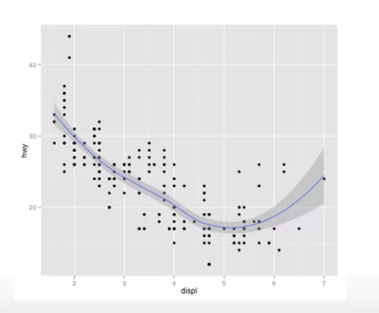
Exploratory Analysis Overview
Content
- Principles of Analytic Graphics
- Exploratory graphs
- Plotting Systems in R
  - base
  - lattice
  - ggplot2
- Hierarchical clustering
- K-Means clustering
- Dimension reduction

Example graph:
qplot(displ, hwy, data = mpg, geom = c(“point”, “smooth”))

Principles of Analytic Graphics
- Principle 1: Show comparisons
- Principle 2: Show causality, mechanism, explanation
- Principle 3: Show multivariate data
- Principle 4: Integrate multiple modes of evidence
- Principle 5: Describe and document the evidence
- Principle 6: Content is king
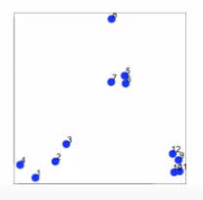

K-means clustering – example
set.seed(1234)
par(mar = c(0, 0, 0, 0))
x <- rnorm(12, mean = rep(1:3, each = 4), sd = 0.2)
y <- rnorm(12, mean = rep(c(1, 2, 1), each = 4), sd = 0.2)
plot(x, y, col = “blue”, pch = 19, cex = 2)
test(x + 0.05, y + 0.05, labels = as.character(1:12))

Reproducible Research Overview'
Creating code and documents that will completely recreate all the analysis you've done in a transparent way so you can communicate that to other people.
Content
- Structure of a Data Analysis
- Organizing a Data Analysis
- Markdown (reproducable)
- LaTeX
- R Markdown
- Evidence-based data analysis (data analysis based on what is best practices at the time)
- Rpubs (how to publish your data)

Steps in data analysis
- Define the question
- Define the ideal data set
- Determine what data you can access
- Obtain the data
- Clean the data
- Exploratory data analysis
- Statistical prediction/modeling
- Interpret results
- Challenge results
- Synthesize/write up results
- Create reproducible code

Which files are components of data analysis
- Data
  - Raw data
  - Processed data
- Figures
  - Exploratory figures
  - Final figures
- R code
  - Raw scripts
  - Final scripts
  - R Markdown files (optional)
- Text
  - Readme files
  - Text of analysis

Statistical Inference Overview
Foundational ideas of involved with extracting generalizable information from data.
Content
- Basic probability
- Likelihood
- Common distributions
- Asymptotics
- Confidence intervals
- Hypothesis tests
- Power
- Bootstrapping
- Non-parametric tests
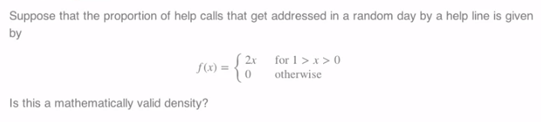
- Basic Bayesian statistics

Normal distribution
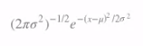
A random variable is said to follow a normal or Gaussian distribution with mean μ and variance σ² if the associated density is

If X is a RV with this density then E[X] = μ and Var(X) = σ²
We write X ~ N(μ,σ²)
When μ = 0 and σ = 1 the resulting distribution is called the standard normal distribution
The standard normal density function is labeled Φ
Standard normal RVs are often labeled Z

Example: distribution of height
Example bootstrap code (Use the data itself to measure the variability, how generalizable are the answers we got for our analysis)
B <- 1000
n <- length(gmVol)
resamples <- matrix(sample(gmVol,
n * B,
replace = TRUE),
B, n)
medians <- apply(resamples, 1, median)
sd(medians)

quantile(medians, c(.025, .975))


Regression Models Overview
One of the most widely used tools for performing any statistical or data science analysis is regression.
Some would say it's one other form of creating a supervised predictive function. One of the more interpretable and easy to use tools to explain to others outside of the data science community.
Content
- Linear regression
- Multiple Regression
- Confounding
- Residuals and diagnostics
- Prediction using linear models
- Model misspecification
- Scatterplot smoothing/splines
- Machine learning via regression
- Resampling inference in regression, bootstrapping, permutation tests
- Weighted regression
- Mixed models (random intercepts)

Basic regression model with additive Gaussian errors
Least squares as an estimation tool. How do we do inference?
Consider developing a probabilistic model for linear regression
Y_{i} = B₀ + B₁X_{i} + c_{i}
Here the ϵ_{i} are assumed iid N(0, σ^{2).}
Note, E[Y_{i}|X_{i} = x_{i}] = μ_{i} = B₀ + B₁x_{i}
Note, Var(Y_{i}|X_{i} = x_{i}) = σ^{2.}
Likelihood equivalent model specification is that the Y_{i} are independent N( μ_{i}, σ²).

Mathematical; deriving the basic ideas behind the regression model.

Multivariable regression analyses
An insurance company is interested in how last year's claims can predict a person's time in the hospital this year.
They want to use an enormous amount of data contained in claims to predict a single number. Simple linear regression is not equipped to handle more than one predictor
What are the consequences of adding lots of regressors?
Overfitting (including features not related to Y)
Undefitting (excluding improtant features)

Practical Machine Learning Overview
Hands on application of machine learning in R where we look at the R packages to take data and perform machine learning.
Content
- Prediction study design
- Types of Errors
- Cross validation
- The caret package
- Plotting for prediction
- Preprocessing
- Predicting with regression
- Predicting with trees
- boosting
- bagging
- model blending
- forecasting

Basic Terms
In general, Positive = identified and negative = rejected. Therefore:
- True Positive = correctly identified
- False Positive = incorrectly identified
- True negative = correctly rejected
- False negative = incorrectly rejected

Medical testing example:
- True positive = Sick people correctly diagnosed as sick
- False positive = Healthy people incorrectly identified as sick
- True negative = Healthy people correctly identified as healthy
- False negative = Sick people incorrectly identified as healthy
http://en.wikipedia.org/wiki/Sensitivity_and_specificity

Correlated Predictors
Preprocessing out data that have correlated predictors (removing them from the training set)

Basic idea behind boosting
More a technical idea, but with functions in R can improve your prediction accuracy.
- Start with a set of classifiers h₁,...h_{k}
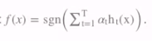
  - Examples: All possible tree, all possible regression models, all possible cutoffs.
- Create a classifier that combines classification functions:
  - Goal is to minimize error (on training set)
  - Iterative, select one h at each step
  - Calculate weights based on errors
  - Upweight missed classifications and select next h
http://webee.technion.ac.il/people/rmeir/BoostingTutorial.pdf
Building Data Products Overview
How you share R packages and functions that you've made. One of the best ways to get your name out there as a data scientist.
Content
- R packages
  - devtools
  - roxygen
  - testthat
- rCharts (interactive charts)
- Slidify (interactive apps)
- Shiny (interactive apps)

Creating R packages for other engineers that help them do their analysis.

Rcharts is good for marketing and allows users to interact with the data.

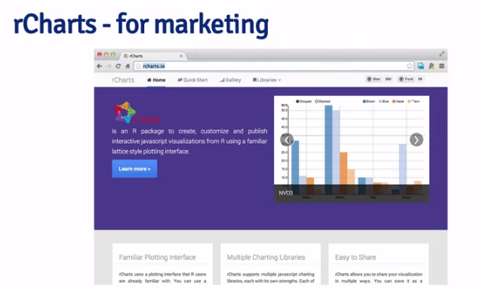
Shiny – You can now use R to build intricate and involved web applications. The users are allowed to interact with data and your analysis.

Introdution to the Command Line Interface
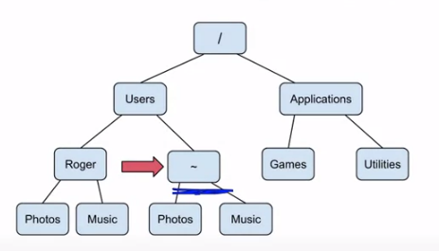
Working with files or folders that involves typing commands instead of pointing and clicking. Extremely useful for data science.
What is the Command Line Interface? CLI
For windows we will use “Git Bash”
Usefulness:
- Navigate folders
- Create files, folders, and programs
- Edit files, folders, and programs
- Run computer programs (one of the main ways we will be using CLI)
Basics of Directories
- Directory means folder
- One directory “up” goes to the directory that contains the current directory.
- A sub-directory is a directory inside your current directory.
- The root directory is represented by a slash: /
  - The root directory contains all the other directories.
- The home directory is represented by a tilde: ~
  - Where you log in when you log into your computer (photos, music, R functions)
CLI Basics
- What shows up initially is the prompt. (ie. Sean$)
- When you open the CLI you start in your home directory.
- The working directory is the directory you are in at the moment.
- The path is the directory chain from the root directory. (pwd)
CLI Commands Background
- CLI commands follow this recipe: commands flags arguments
- command is the CLI command which does a specific task
- flags are options we give to the command to trigger certain behaviors, preceded by a -
- arguments can be what the command is going to modify, or other options for the command
- Depending on the command, there can be zero or more flags and arguments
- For example pwd is a command that requires no flags or arguments
CLI Commands
pwd | Path from root to current directory | /Users/jeff
clear | Clear out everything, with just a prompt remaining
ls | All the files and folders in your current directory | Desktop Photos
ls -a | Lists hidden and unhidden files and folders | Desktop Photos .Trash
ls -al | Shows details about hidden and unhidden files and folders, including the size of the files or folders. -a and -al are flags for ls; they are preceded by a -  They can be combined into the flag: -al
cd | “change directory”. Takes as an argument the directory you want to visit. With no argument, takes you to your home directory. | cd Photos
cd .. | Allows you to change directory to one level above your current directory
mkdir | “make directory”. Takes as an argument the name of the directory you're creating | mkdir documents
touch | Creates an empty file. Takes as an argument the name of the file you're creating. | touch new_file
cp | “copy”. Takes as its first argument a file and as its second argument the path to where you want the file to be copied | cp test_file documents
cp -r | “recursive”. For copying the contents of directories | cp -r documents More_docs
rm | “remove”. Takes the name of the file you wish to remove as its argument | rm test_file
rm -r | “recursive”. For removing entire directories. | rm -r More_docs
mv | “move”. Can move files between directories | mv newfile Documents
mv | Can also be used to rename files | mv new_file renamed_file
echo | Prints out the arguments you provide. Useful for printing the contents of particular variables that have been stored. | Echo Hello World!  (prints: Hello World!)
date | Will print today's date

Introduction to Git
“Version control is a system that records changes to a file or set of files over time so that you can recall specific versions later.”
- Many of us constantly create something, save it, change it, then save it again.
- Version (or revision) control is a means of managing this process in a reliable and efficient way.
- Especially important when collaborating with others

What is Git?
“Git is a free and open source distributed version control system designed to handle everything from small to very large projects with speed and efficiency.”
- Created by the same people who developed Linux
- The most popular implementation of version control today
- Everything is stored in local repositories on your computer
- Operated from the command line

Configure Username and Email
- Each commit to a Git repository is tagged with the username of the person who made the commit.
- This must be typed in once:
$ git config -–global user.name “Your Name Here”
$ git config -–global user.email “your_email@example.com”
3. Now type the following to confirm your changes
$ git config -–list
4. You can close Git Bash with the command:
$ exit

What's Next?
- GitHub requires Git. GitHub is a web-based platform that lets you do cool stuff
- Once GitHub is up and running, we'll show you how to start using these tools to your benefit

Introduction to GitHub
A more recent website that has been set up that allows people to collaborate on projects together on a bigger scale, and is really where the power of Git comes into play.
What is GitHub?
- Allows users to “push” and “pull” their local repositories to and from remote repositories on the web.
- Provides users with a homepage that displays their public repositories
- Users' repositories are backed up on the GitHub server in case something happens to the local copies
- Social aspect allows users to follow one another and share projects
Additional Benefits
- Learning how someone else's code work is a great way to identify people who would be good to work with.
- Other people will also contribute for free to make your software better, because they're interested
Set Up a GitHub Account
- Go to the GitHub homepage at https://github.com/
- password: regular shoot password 31
- email: peter@impactradius.com
- Username: Peter-32
Navigating GitHub
- Be sure to go through their tutorials
- The username in the top right corner takes you to your GitHub profile
  - Shows all your activity on GitHub and who you are and what you're interested in.
  - Show off your skills here.
GitHub Tutorial
Create a directory like: mkdir ~/test-repo. Then inside it say “git init”
- Connecting over HTTPS
  - Clone with HTTPS
    - The https:// clone URLs are available on all repositories, public and private. They will provide you with access based on your given permissions.
    - When you use “git fetch”, “git pull”, or “git push” you will be asked for your GitHub username and password.
  - Cache your GitHub password in Git
    - Type this into the command line to store your credentials:
    - git config --global credential.helper wincred
- Create a Repository
  - To put your project on GitHub you'll need a repository.
  - Upper-right corner of any page, click “+”, and then click New repository
  - Give your repository a name and optionally a description
  - Choose between public or private. Public is a good idea at first. Private only allows access to collaborators and yourself.
  - Select Initialize this repository with a README.
  - Click Create repository
- Commit your first change
  - README is a great place to describe your project in more detail, or add some documentation such as how to install or use your project.
  - In your repository list of files, click README.md
  - Above the file's content, click the pencil
  - One the Edit file tab, type some information about yourself
  - Above the new content, click Preview changes.
  - The new content is in green.
  - At the bottom of the page, type a short, meaningful commit message that describes the changes you made to the file.
  - Below the commit message fields, decide whether to add your commit to the current branch or to a new branch. If your current branch is “master”, you should choose to create a new branch for your commit and then create a pull request.
  - Click Propose file change.
- Create a Pull Request
    - To propose and collaborate on changes to a repository. These changes are proposed in a branch, which ensures that the “master” branch is kept clean and tidy.
    - On GitHub, navigate to the repository from which you'd like to propose changes.
    - In the “Branch” menu, choose the branch that contains your commits.
    - To the left of the “Branch” menu, click the green Compare and Review button.
    - The Compare page will automatically select the base and compare branches; to change these, click Edit.
    - On the Compare page, click Create pull request.
    - Type a title and description for your pull request
    - Click Create pull request
    - After your pull request has been reviewed, it can be merged into the repository.
- Fork a Repo
    - A fork is a copy of a repository. Forking allows you to freely experiment with changes without affecting the original project. Can be used to propose changes, or to use someone else's project as a starting point.
    - Rather than logging a bug, instead:
      - Fork the repository, make the fix, and submit a pull request to the project owner.
3. Two-step process. Navigate to the repository (ie. https://github.com/octocat/Spoon-Knife)
4. In the top-right corner of the page, click Fork.
- Setup to keep your fork synced
  - It is good practice to regularly sync your fork with the upstream repository. You'll need to use the Git command line.
  - Create a local clone of your fork; you need the files in the repository on yoru computer.
    - Navigate to your fork.
    - In the right sidebar of your fork's repository page, click copy the clone URL for your fork.
    - Open Git Bash.
    - Type git clone then paste the URL you copied in Step 2.
    - Press Enter and your local clone with be created.
  - Configure Git to sync your fork with the original repository
    - Configuring it to pull changes from the original into the local clone.
    - Navigate to the repository
    - Copy the clone URL
    - Open Git Bash
    - Change directories to the location of the fork you cloned earlier.
    - Type “git remote -v” and press Enter.
    - Type “git remote add upstream”, and then paste the URL you copied in Step 2 and press Enter.
    - To verify the new upstream repository you've specified for your fork, type “git remote -v” again. You should see the URL for your fork as “origin”, and the URL for the original repository as “upstream”.
- Syncing a Fork
  - Now you can sync your fork with some commands.
  - Open Git Bash
  - Change working directory to the local project
  - Fetch the branches “git fetch upstream”. Commits to “master” will be stored in a local branch, “upstream/master”.
  - Check out your fork's local “master” branch “git checkout master”
  - Merge the changes from “upstream/master” into your local “master” branch. This brings your fork's “master” branch into sync with the upstream repository, without losing your local changes. “git merge upstream/master”. If your local branch didn't have any unique commits, Git will instead perform a “fast-forward”
  - This only syncs your local copy, to update your fork on GitHub, you must push your changes.
git commit origin
- Be Social
  - Follow people
  - Watch a Project
  - Let the original author know about your changes by sending them a pull request (green bar)
  - Issues – If you are collaborating on a project and come across problems, click on the “!”
  - Organizations – Allow you to collaborate with multiple people on one project.
  - Explore – Discover interesting projects in the “Explore GitHub” and “Trending page”. You can star projects you find interesting and want to come back to later. The stars page shows the pages you've starred.
    - Explore GitHub
    - Trending Page
    - Stars Page
Coursera Notes on using GitHub
mkdir repo-name
git init
git remote add origin [pasteURL]
To fork, click “Fork”. To create a local repository use:
git clone [pasteURL]

Basic Git Commands
The workspace is the directories you're working with on your computer. The index tells git what files it should be controlling under version control. Local repository are the files that are stored or version controlled on your local computer. Remote repository, in our case it will always be GitHub.

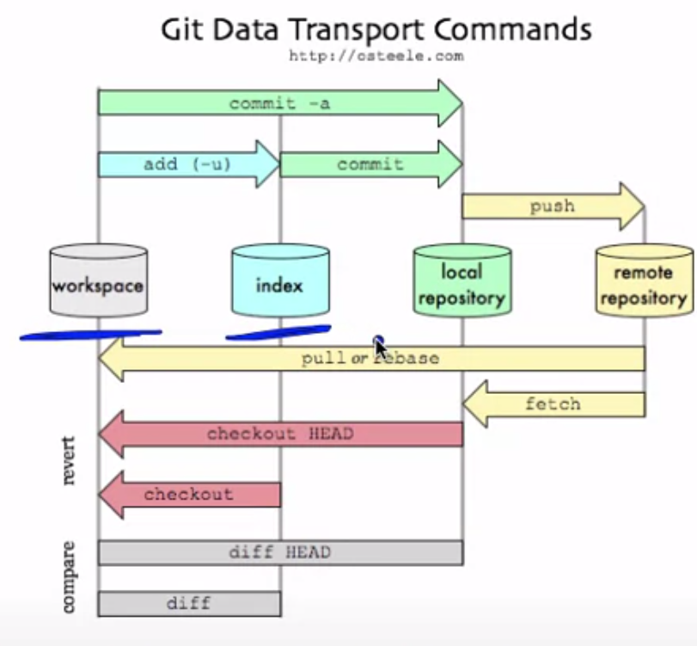
The idea is you're starting off in your workspace and you create a new file, the first thing you need to do is add that file to the index (add (-u)) so that Git knows to monitor that file and keep up with all of its changes. Then you need to “commit” the file to put it in the local repository. As you make changes you keep committing those changes. Finally after you've done a few commits, you'll issue a push command to update the remote repository.

Adding (adding to the index)
Suppose you add new files to a local repository under version control
You need to let Git know that they need to be tracked
- git add . adds all new files
- git add -u updates only the changes (or new files)
- git add -A does both of the previous
You should do this before committing

Committing
You have changes you want to commit to be saved as an intermediate version
You type the command:
- git commit -m “message” where message is a useful description of what you did
This only updates your local repo, not the remote repo on GitHub.
Pushing
You have saved local commits you would like to update on the remote (Github)
You type the command
- git push

Branches
Sometimes you are working on a project with a version being used by many people
You may not want to edit that version
You can create a branch with the command
- git checkout -b branchname
To see what branch you are on type:
- git branch
To switch back to the master branch type
- git checkout master

Pull requests
If you fork someone's repo or have multiple branches you will both be working seperately
Sometimes you want to merge in your changes into the other branch/repo
To do so you need to send a pull request.
This is a feature of GitHub

Time to be a hacker!
Git documentation
Github help
Google/Stack Overflow are great for GitHub.

Basic Markdown (.md files)
Markdown Syntax
Headings:
## This is a secondary heading
### This is a tertiary heading

Unordered Lists:
* first item in list
* second item in list
* third item in list

Getting markdown help
An introduction to markdown
Click the MD button in Rstudio for a quick guide
R markdown

Installing R Packages
When you download R from the Comprehensive R Archive Network (CRAN), you get the “base” R system
The base R system comes with basic functionality; implements the R language
One reason R is so useful is the large collction of packages that extend the basic functionality of R
R packages are developed and published by the larger R community

Obtaining R Packages
The primary location for obtaining R packages is “CRAN”
For biological applications, many packages are available from the “Bioconductor Project”
You can obtain information about the available packages on CRAN with the available.packages() function
a <- available.packages()
head(rownames(a), 3) ## Show the names of the first few packages


There are approximately 5200 packages on CRAN covering a wide range of topics
A list of some topics is available through the “Task Views” link which groups together many R packages related to a given topic.

Installing an R Package
Packages can be installed with the install.packages() function in R
To install a single package, pass the name of the package to the install.packages() function as the first argument
The following code installs the slidify package from “CRAN” onto your computer
Any packages on which this package depends will also be downloaded and installed.
install.packages(“slidify”)
install.packages(c(“slidify”, “ggplots2”, “devtools”))

Installing an R Package from Bioconductor
To get the basic installer and basic set of R packages
source(“http://bioconductor.org/biocLite.R”)
biocLite()
Place the names of the R packages in a character vector
biocLite(c(“GenomicFeatures”, “AnnotationDbi”))
http://www.bioconductor.org/install/

Loading R Packages (After you've installed them)
Installing a package does not make it immediately available to you in R; you must load the package
The library() function is used to load packages into R
The following code is used to load the ggplot2 package into R
library(ggplot2)
Any packages that need to be loaded as dependencies will be loaded first, before the named package is loaded
NOTE: Do not put the package name in quotes!
Some packages produce messages when they are loaded (but some don't)
After loading a package, the functions exported by that package will be attached to the top of the search() list.
library(ggplot2)
search()
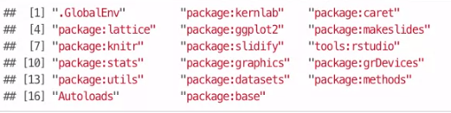

Summary
R packages provide a powerful mechanism for extending the functionality of R
R packages can be obtained from CRAN or other repositories
The install.packages() can be used to install packages at the R console
The library() function loads packages that have been installed so that you may access the functonality in the package

Installing Rtools (Macs don't need this)
A collection of tools necessary for building R packages in Windows
Available for download at http://cran.r-project.org/bin/windows/Rtools/
(Used later in developing data projects)
Select the .exe download link from the table that corresponds to your version of R

Install devtools
Once Rtools installs open Rstudio
Install the devtools R package
find.package(“devtools”)
install.packages(“devtools”)

Verify Rtools installation
After devtools is done installing, load it using
library(devtools)
find_rtools() # This should return TRUE in the console if your Rtools installed properly

Types of Data Science Questions
In approximate order of difficulty (ascending order)
Descriptive
Exploratory
Inferential
Predictive
Causal
Mechanistic

About descriptive analysis
Goal: Describe a set of data (what is going on)
- The first kind of data analysis performed
- Commonly applied to census data (http://www.census.gov/2010census/)
- The description and interpretation are different steps
- Descriptions can usually not be generalized without additional statistical modeling

About exploratory analysis
Goal: Find relationships you didn't know about
- Exploratory models are good for discovering new connections
- They are also useful for defining future studies
- Exploratory analysis are usually not the final say
- exploratory analysis alone should not be used for generalizing/predicting
- Correlation does not imply causation

About inferential analysis
Goal: Use a relatively small sample of data to say something about a bigger population
- Inference is commonly the goal of statistical models
- Inference involves estimating both the quantity you care about and your uncertainty about your estimate
- Inference depends heavily on both the population and the sampling scheme
ie. Effect of Air polution control on life expectancy in the US: An analysis of 545 US counties from 2000 to 2007.

About prediction analysis
Goal: To use the data on some objects to predict values for another object
- If X predicts Y it does not mean that X causes Y
- Accurate prediction depends heavily on measuring the right variables
- Although there are better and worse prediction models, more data and a simple model works really well.
- Prediction is very hard, especially about he future

About causal analysis
Goal: To find out what happens to one variable when you make another variable change
- Usually randomized studies are required to identify causation
- There are approaches to inferring causation in non-randomized studies, but they are complicated and sensitive to assumptions.
- Causal relationships are usually identified as average effects, but may not apply to every individual
- Causal models are usually the “gold standard” for data analysis
About mechanistic analysis
Goal: Understand the exact changes in variables that lead to changes in other variables for individual objects
- Incredibly hard to infer, except in simple situations
- Usually modeled by a deterministic set of equations (physical/egnienering science)
- Generally the random component of the data is measurement error
- If the equations are known but the parameters are not, they may be inferred with data analsyis

What is data?
Data are values of qualitative or quantitative variables, belonging to a set of items (set of items is sometimes called population)
Variables (or features): measurement or characteristic of an item
Qualitative: Country of origin, gender, treatment
Quantitative: Height, weight, blood pressure

The data is the second most important thing
The most important thing in data science is the question
The second most important is the data
Often the data will limit or enable the questions
But having data can't save you if you don't have a question (not being driven by the fact that you have data)
If you don't have the data you may need to modify your question.

What about big data
Big data is different to different people. Without a computer it might be 1000 numbers. For others it might be much much larger. The world's information is doubling every two years, in 2011 there will be 1.8 zettabytes created.

Regardless of the size of the data, you need the right data. For a given question, a reasonable answer can't always be gained from a body of data.

Experimental Design
Why you should care – an exciting result
Example: Used genes to predict what kind of chemotherapy you might respond to best. Unfortunately, they preformed a very flawed study design and very flawed statistical analysis pointed out later. This led to lawsuits.

A very exciting result can lead you astray if you aren't very careful about experimental design and analysis. Care about the analysis plan.

Have a plan for sharing the data (ie. GitHub)

Formulate your question in advance
Example Question: Does changing the text on your website improve donations?
Experiment: Randomly show visitors one version or the other. Measure how much they donate. Determine which is better.

Statistical Inference
A large component of data science
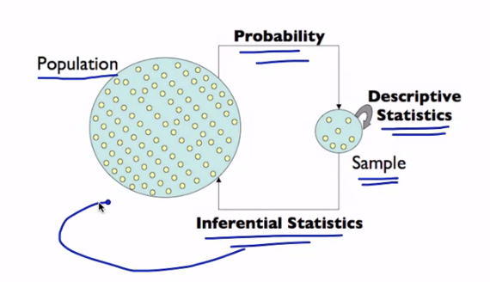
Using inferential statistics you determine if what played out on the small sample will occur in the population.

Confounding
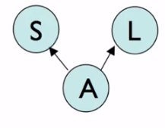
Shoe size is correlated with literacy because babies have small shoes. However, shoe size doesn't have a causal relationship with literacy. is_adult is a confounder for the relationship between shoe size and literacy.
Pay attention to what the other variables might be causing a relationship
Correlation is not causation: you must prove that the correlation isn't
caused by other variables we did not measure.

Randomization and blocking
If you can (and want to) fix a variable
- Website always says Obama 2014 on it
If you don't fix a variable, stratify it
- If you are testing sign up phrases and have two website colors, use both phrases equally on both
If you can't fix a variable, randomize it

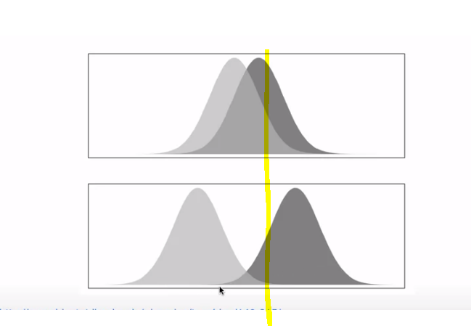
For prediction you need the distributions to be like the bottom figure. For the top figure, given we're at the yellow point, it is likely that they came from the dark gray group, and also likely they came from the light gray group. But for the bottom figure, it we can more accurately predict that they are part of the dark gray group.

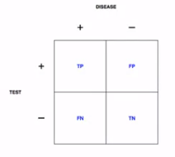

Prediction key quantities

Sensitivity → Pr( positive test | disease )
Specificity → Pr ( negative test | no disease )
Positive Predictive Value → Pr( disease | positive test )
Negative Predictive Value → Pr( no disease | negative test )
Accuracy → Pr( correct outcome )

Data dredging is testing 20 different times with 95% confidence interval and having 1 successful test and claiming that it is significant enough.

Summary
Good experiments
- Having replication
- Measure variability
- Generalize to the problem you care about
- Are transparent (in the code and data)
Prediction is not inference; both can be important; beware data dredging

